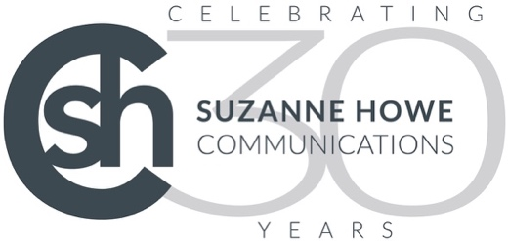

11 March 2026

Celebrating SHC’s 30th anniversary with a cleaning industry
round table stakeholder lunch

Suzanne Howe Communications (SHC), founded in 1996, began its 30th anniversary celebrations in February 2026 by hosting its first stakeholder engagement lunch for the cleaning sector at a London restaurant.

Our guests attended, including Ross Osbourne (MSC), Michelle Marshall (European Cleaning Journal), Rachael Carley (Carley Coaching), Sam Worden (NGB Clean), Kate Lovell (Cleanology), Hannah Taylor (The Lens Box), Neil Spencer Cook (BICSc), Amy Carter (Kimberly-Clark Professional) and Deborah Sparkes (SHC).

Held in a relaxed and informal setting, the lunch provided an opportunity to discuss key trends, challenges and opportunities in the cleaning industry.

SHC is in the process of applying for B-Corp certification, so while the discussions at the stakeholder lunch focused on the trends, challenges and opportunities facing the cleaning industry, we also looked at B-Corp and its values, and how they are reflected in the cleaning sector.

Here is a summary of the discussions…

Who are our stakeholders?
Stakeholders include everyone involved in or affected by the cleaning and facilities sector: businesses represented at the meeting, cleaning operatives, management teams, suppliers, clients, media partners, and charities. Bringing these groups together is important because each group influences how the industry operates and how improvements in sustainability, working conditions, and social impact are achieved.
Cleaning operatives are among the most important stakeholders. Their experiences shape the effectiveness of industry initiatives. While some organisations offer career pathways, many operatives are primarily concerned with earning fair pay above the minimum wage. Meaningful engagement requires clear communication, training, and visible progression opportunities.

Organisations working across the sector, including social enterprises and suppliers, also play a role in introducing initiatives that support operatives and improve working conditions. However, lasting change depends on collaboration between all stakeholders and a stronger focus on the needs, development, and long-term career opportunities of cleaning operatives.

What would you suggest to a large organisation trying to improve cleaning operative satisfaction and what are the biggest obstacles?

The discussion highlighted that improving cleaning operative satisfaction is possible but challenging, largely due to resistance to change across the industry.

Increasing pay, ideally ensuring operatives are paid above minimum wage, is one of the most immediate ways to improve satisfaction. However, organisations often struggle to balance profitability with fair pay. A broader cultural shift is also needed to raise the status and recognition of cleaning operatives, whose demanding work is often undervalued despite its importance in environments such as hospitals, where cleanliness is essential.

Building managers and property owners play a key role in driving improvements but are often resistant to change. Although the COVID-19 pandemic briefly increased appreciation of cleaning, this shift was short-lived.

Cleaning operatives are frequently viewed as the lowest-ranking staff despite their critical role in hygiene and public health. Expanding industry awards – such as the Kimberly-Clark Professional Golden Service Awards and the European Cleaning Awards – to include building owners and wider stakeholders could help raise the sector’s profile. Research and data are also essential to demonstrate the value of high-quality cleaning and support greater investment.

What market trends should we be tracking?
Social impact has emerged as a critical trend, particularly in industries where frontline staff form the backbone of service delivery. In the cleaning sector, this means prioritising the welfare of cleaning operatives. Although data collection on performance and social procurement has increased, the challenge lies in turning this information into meaningful outcomes. Excessive tracking without clear objectives risks creating innovation for its own sake rather than delivering genuine sustainability and social value.
Discussion insights highlighted the need for accountability and measurable impact. With around 80% of the industry made up of frontline operatives, their treatment and support must be central to strategy. Initiatives such as sustainable cleaning practices and staff-focused social programmes can demonstrate visible impact and strengthen engagement. Sharing real stories, such as volunteering with homeless shelters, helps inspire building owners, estate managers, and public figures to take part and raise awareness.

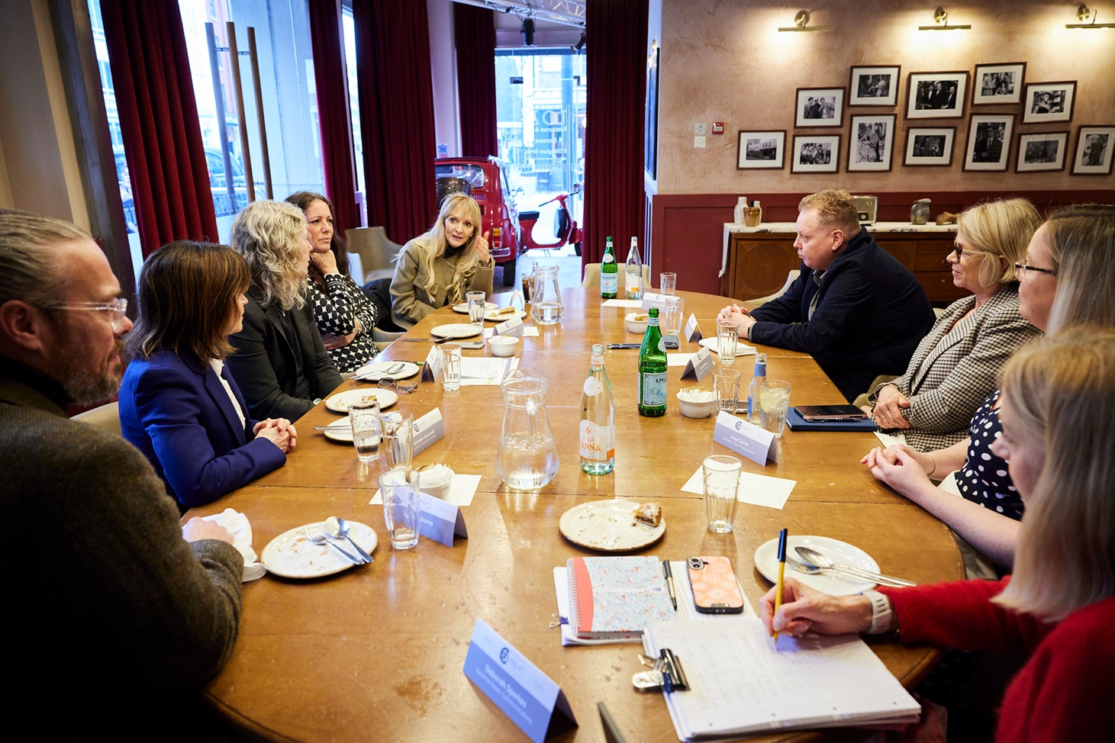
Collaboration with industry bodies including BICSc, BCC, CHSA, CSSA and WCEC can further promote social responsibility and operational excellence. Through targeted campaigns and PR outreach, organisations can encourage sectors such as Education, HoReCa, Facilities Management and Retail to prioritise social value and sustainability in property management and operations.

www.suzannehowe.com

Ends

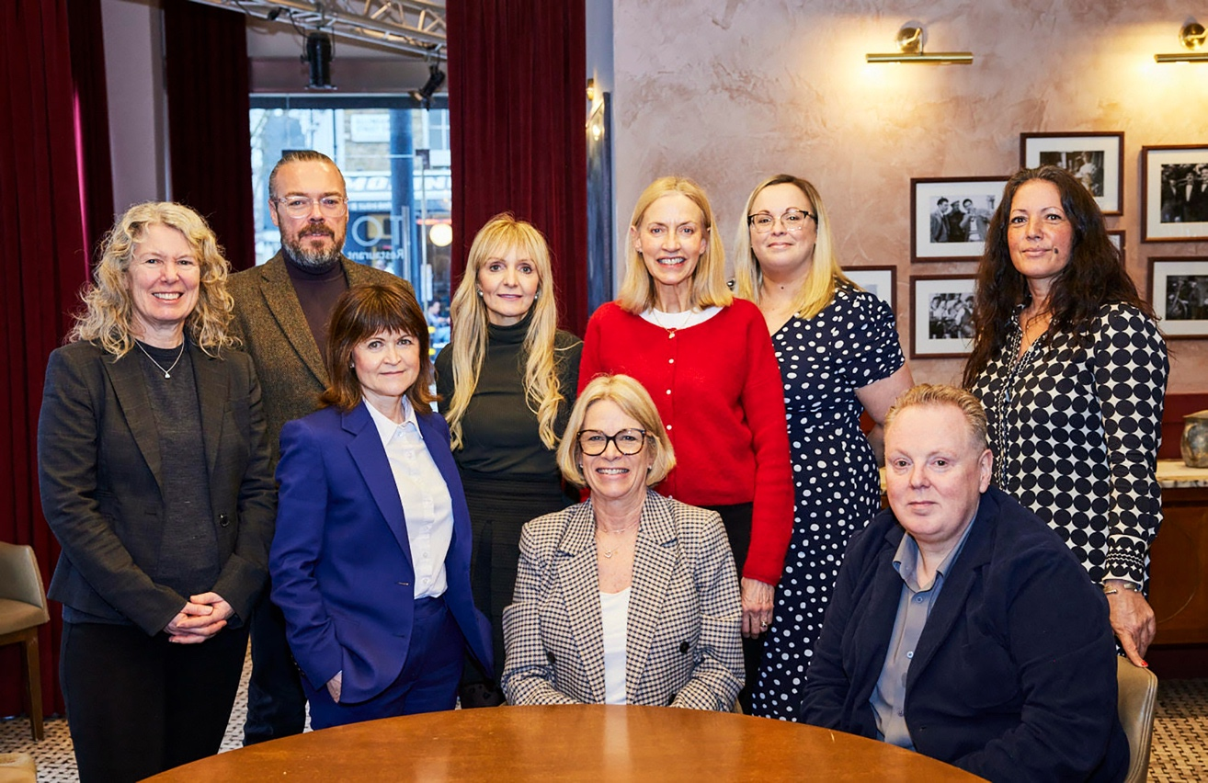
Photographs courtesy: Hannah Taylor, The Lens Box.

For further information, please contact:
Bill Bruce
Suzanne Howe Communications
Tel: +44 (0)2034 680923
Email: bill@suzannehowe.com
Web: www.suzannehowe.com

Notes for editors:

About Suzanne Howe Communications
Founded by experienced PR professional Suzanne Howe in 1996, Suzanne Howe Communications (SHC) is widely recognised as a specialist trade PR and marketing agency.

Based in Kent, SHC operates in four sectors – packaging, food, cleaning & FM, and furniture. The talented SHC team also has experience in sustainability communications. SHC includes a hand-picked team of professionals delivering PR, social media management, marketing strategy and content generation.

Clients have direct access to its combined knowledge and skills and can be assured that the senior team give business direction and support at the level clients require. SHC works with experienced marketing partners, offering clients integrated and creative PR and marketing campaigns, website design, exhibitions and digital marketing.

Please note:
Suzanne Howe Communications (SHC) has supported the Copyright Licensing Association (CLA) and the National Licencing Association (NLA) for many years. We are aware of the great work they do in the world of journalism and publishing. We see our licences as a way of giving back and therefore they form part of our Sustainable and ESG commitment as a business. We would like to take this opportunity to thank you for the coverage you might give our client. We might wish to use the coverage on our social channels to promote our clients but also to thank you. If you would prefer that we didn’t share your coverage online, please make this known to SHC. Thank you very much.

